Military Institute of Science & Technology (MIST)

Department of Electrical, Electronic and Communication Engineering

CSE-372 (December 2023)

Microprocessor And Interfacing Laboratory

Laboratory

**Final Project Report**

**Section: B Group: 08**

Automatic Hand Wash Dispenser Using

Arduino

**Course Instructors:**

**Wg Cdr Toyobur Rahman, Instructor Class ‘A’ (Associate Professor)**

**Hasan Monir, Assistant Professor**

**Nishat Tasnim, Lecturer**

**Nazifa Nawar, Lecturer**

**Signature of Instructor: ___________________________________________________**

**Academic Honesty Statement:**



*“In signing this statement, We hereby certify that the work on this project is our own and that we have not copied the work of any other students (past or present), and cited all relevant sources while completing this project. We understand that if we fail to honor this agreement, We will each receive a score of ZERO for this project and be subject to failure of this course.”*

Signature: ______________________ Signature:______________________

Full Name: Nasif Ahmed Rafe Full Name: Flg Offr Imran Hossain

Student ID: 202116072 Student ID: 202116160

Signature: _____________________ Signature:______________________

Full Name: Safin Tahmid Full Name: Lt Olid Murad

Student ID: 202116082 Student ID: 201916083

**Table of Contents**

**1** **Abstract 1**

**2** **Introduction 1**

**3** **Design 2**

3.1 Problem Formulation (PO(2)) 2

3.1.1 Identification of Scope 2

3.1.2 Literature Review 2

3.1.3 Formulation of Problem 3

3.1.4 Analysis 3

3.2 Design Method (PO(1)) 4

3.3 Circuit Diagram 4

3.4 Full Source Code of Firmware 5

3.5CAD/Hardware design 8

3.7 8

**4** **Implementation 8**

4.1 Description 8

**5** **Design Analysis and Evaluation 9**

5.1 Novelty 9

5.2 Design Considerations (PO(3)) 9

5.2.1 Considerations to public health and safety 9

5.2.2 Considerations to environment 9

5.2.3 Considerations to cultural and societal needs 10

5.3 Investigations (PO(4)) 10

5.3.1 Design of Experiment 10

5.3.2 Data Collection 11

5.3.3 Results and Analysis 11

5.3.4 Interpretation and Conclusions on Data 11

5.4 Limitations of Tools (PO(5)) 11

5.5 Impact Assessment (PO(6)) 11

5.5.1 Assessment of Societal and Cultural Issues 11

5.5.2 Assessment of Health and Safety Issues 11

5.6 Sustainability Evaluation (PO(7)) 11

5.7 Ethical Issues (PO(8)) 12

**6** **Reflection on Individual and Team work (PO(9)) 12**

6.1 Individual Contribution of Each Member 12

6.2 Mode of TeamWork 12

6.3 Diversity Statement of Team 12

6.4 Log Book of Project Implementation 13

**7** **Communication to External Stakeholders (PO(10)) 13**

7.1 Executive Summary 13

7.2 User Manual 14

7.3 Github Link 14

7.4 YouTube Link 14

**8** **Project Management and Cost Analysis (PO(11)) 14**

8.1 Bill of Materials 14

8.2 Calculation of Per Unit Cost of Prototype 14

8.3 Calculation of Per Unit Cost of Mass-Produced Unit 15

**9****Future Work (PO(12)) 15**

**10** **References 15**

# Abstract

|  |
| --- |
| The COVID-19 pandemic has radically affected life for almost everyone around the globe, and makers are no exception. With everyone being more careful of their interactions with humans and objects, personal hygiene has taken serious precedence over all other factors in public space. A lot of public places have hand sanitizers for visitors, but they need to be manually pressed. To avoid any contact at all, some no-touch hand sanitizer dispensers are commercially available, but they are expensive and most off-the-shelf commercial sanitizers cannot be automated. In this project, we create a contactless hand sanitizer dispenser that can be used for any press-to-release hand sanitizer available in the market. |

# Introduction

In a world increasingly focused on hygiene and convenience, the integration of technology into everyday tasks has become essential. One such innovation is the automatic handwash dispenser, a smart solution designed to promote cleanliness and efficiency. Powered by Arduino, a versatile microcontroller, this device represents a marriage between technology and sanitation.

The automatic handwash dispenser operates on a simple yet effective premise: detecting the presence of hands and dispensing an appropriate amount of soap or sanitizer without physical contact. By leveraging sensors, pumps, and the programmable capabilities of Arduino, this system offers a hands-free, hygienic approach to personal and public hygiene practices.

Not only does this device minimize the risk of cross-contamination by eliminating direct contact, but it also allows for customization, enabling adjustments in dispensing volumes and timings to suit varying needs and preferences. Whether in public restrooms, healthcare facilities, or homes, the Arduino-based automatic handwash dispenser stands as a testament to the fusion of technology and hygiene, promising a cleaner, safer environment for all.

In this exploration, we'll delve into the components, coding intricacies, and construction of such a system, illustrating how Arduino facilitates the creation of innovative solutions that positively impact daily routines and health standards.

# Design

## Problem Formulation (PO(2))

For our project, the problem was to make hygienic contactless hand wash dispenser to eliminate cross contact. In order to this we needed some sensors to determine the range and function accordingly. Here ultrasonic sensors were used for distance measurement as well as soap level measurement. Arduino used as brain of the device to control everything.

### Identification of Scope

The scope of an Automatic Hand Wash Dispenser using Arduino can be quite extensive and impactful, especially in the context of hygiene and automation. Here are some potential scopes:

1. **Hygiene Maintenance:** Such a device ensures a touchless operation, reducing the spread of germs and infections by eliminating direct contact with the dispenser. It contributes to maintaining hygiene standards in public places, hospitals, kitchens, etc.
2. **Resource Optimization:** By providing a measured amount of soap or hand wash, it helps in conserving resources and reducing wastage. This can be particularly beneficial in places where there's a need to control the amount of soap used, like in public restrooms.
3. **Customization and Control:** Arduino-based systems allow for customization of functionalities. One can program different dispensing amounts, control timing intervals, or incorporate sensors for detecting hand presence, thereby making the dispenser more efficient and user-friendly.
4. **Integration with IoT and Data Collection**: These systems can be integrated with the Internet of Things (IoT), enabling remote monitoring, data collection on usage patterns, and maintenance needs. This data can be used for analytics and ensuring timely refills or maintenance.
5. **Education and Innovation**: Building such a system using Arduino provides an educational platform for students and enthusiasts to understand the basics of automation, sensor integration, programming, and practical applications of technology in everyday life.

### Literature Review

There are millions of germs that live surround us such as in bathroom, kitchens and even on the telephone. It is hard for humans to prevent themselves from having any contact with the contaminated surface. The germs can live in harsh conditions and easily transfers into other surfaces. Once human touched the contaminated surface, the germs on the hands will easily transfer into other by only single touch. The germs on the hands can easily enter into the body through eyes, nose and mouth which then causes sickness (Ejemot, Ehiri, Meremikwu, & Critchley, 2008). In order to remove most of the germs

on the hands, one needs to wash hands as clean as possible and several times per day.Hand washing is the act of cleaning hands in order to remove the germs on hands. Hand washing is very important where it is listed as one of the guidelines for standard precautions that need to be followed by the health care. According to Powers, Armellino, Dolansky, & Fitzpatrick (2016), it is recorded that 63% of the health care will wash their hands after removal of gloves while 82% wash their hands after provision care. This shows that there are still people are not applying hand washing technique. This situation will promote of spreading of germs through contacts.

### Formulation of Problem

The problem under consideration involves the development of automatic hand wash dispenser system, incorporating an ultrasonic sensor, servo motor, and buzzer. The primary objective is to address challenges associated with the accurate measurement of distances and the detection of objects within a predetermined range. Key challenges include the mitigation of inaccuracies stemming from environmental factors that impact ultrasonic wave propagation. Furthermore, the optimization of the servo motor for precise scanning motions is crucial, as is the development of an algorithm capable of efficient real-time data processing. An additional goal is to implement a mechanism that provides timely audible alerts through the buzzer when an object is detected within a range. The problem formulation revolves around resolving these challenges to construct a fully functional and dependable automatic hand wash dispenser system .

## 3.1.4 Analysis

An ultrasonic sensor measures the distance between its transmitter and an obstacle in front using ultrasonic sound waves (operational at 40 KHz) beyond the human audible sound wave range. The transmitter element sends out the ultrasonic wave which is reflected from the target and is picked up by the receiver module. Using the time-of-flight principle and the known speed of sound (~340 m/s), the distance between the sensor and the target is calculated.

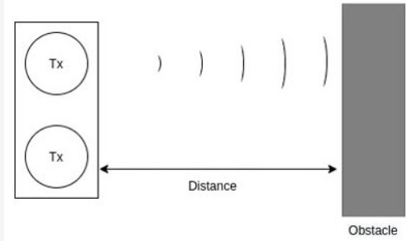

The HC-SR04 module Trigger pin when set HIGH does not immediately set off an ultrasonic wave. Instead, a burst of 8 ultrasonic waves are sent out from the transmitter, invoked on the falling edge of the Trigger pin (after set HIGH). The minimum length of the Trigger pin HIGH pulse needed to invoke the ultrasonic pulse burst is 10 microseconds.

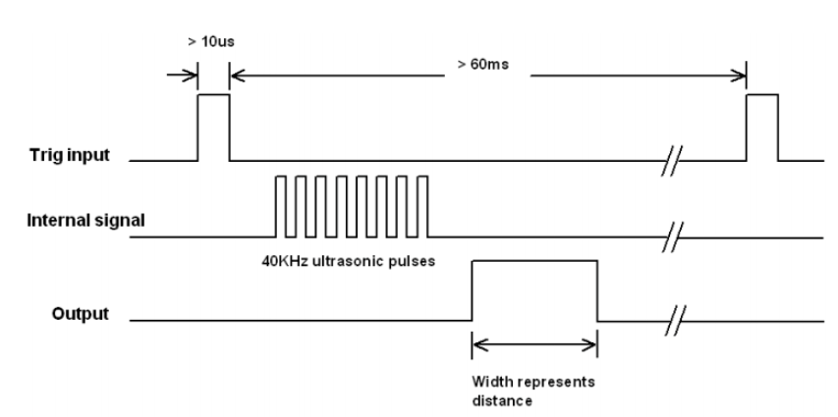

**Servo Motor**

servo motor is the most common position-controlled actuator. It works on the conventional servo-mechanism principle, where a rotary potentiometer measures the position of the shaft based on the varying resistance and feeds it to a comparator. The comparator computes the difference between the reference position value from the controller against the actual position and sends the amplified error signal to the motor. The error amplification is usually a PID loop.

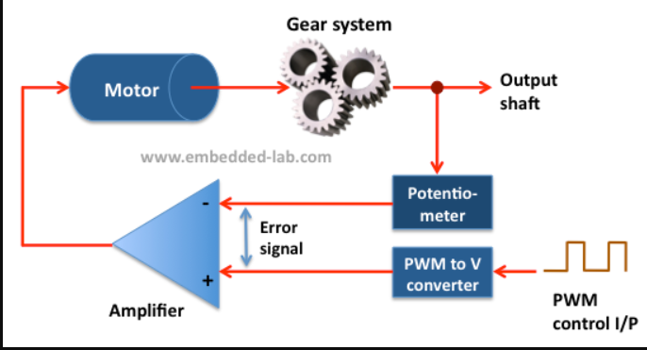

## Design Method (PO(1))

The design method for the sonar-based Automatic Hand Wash Dispenser involves a systematic approach to integrating key components. Here ultrasonic sensors transmits an ultrasonic wave and the wave is reflected by the obstacle. If it is within the range( the range is set in the code) the eco pin activates and gives signal to the Arduino then the Arduino gives signal to the servo motor and the servo motor rotates at a specific angle and thus the liquid is released. If the distance is too close the system gives an alarm through the buzzer. There is also a level indicator to determine the level. If the level is low, then the LED will lit up and indicate the low level of the liquid.

## Circuit Diagram

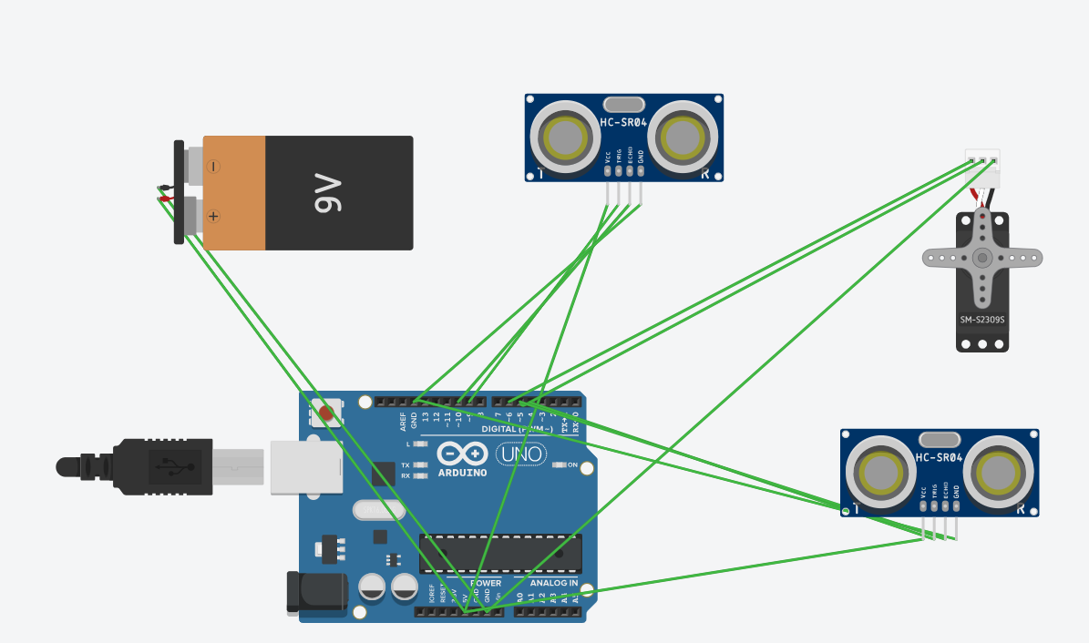

## Full Source Code of Firmware

|  |
| --- |
| #include <Servo.h>// HC-SR04 Echo Pin & Trigger Pin connect to the Arduino Nano Digital Pins#define echo_pin 10#define trigger_pin 9// Servo PWM#define servo_pin 6#define buzzer 3const int trigPin = 4; // Trigger pinconst int echoPin = 5; // Echo pinlong duration2;int distance2;Servo servo_motor;void setup() {pinMode(trigger_pin, OUTPUT);pinMode(echo_pin, INPUT);pinMode(buzzer, OUTPUT); // Added LED pinpinMode(trigPin, OUTPUT);pinMode(echoPin, INPUT);Serial.begin(9600);servo_motor.attach(servo_pin);}void loop() {digitalWrite(trigger_pin, LOW);delayMicroseconds(2);digitalWrite(trigger_pin, HIGH);delayMicroseconds(10);digitalWrite(trigger_pin, LOW);long duration = pulseIn(echo_pin, HIGH);double distance = duration * 0.034 / 2;Serial.print(distance);// If the distance read by the sensor is less than 10 cm and more than the minimum 3 cm,// then it is assumed that there is a hand under the sanitizerif ((distance > 3) && (distance < 10)) {servo_motor.write(150);delay(1000);}servo_motor.write(0);// Trigger the ultrasonic sensordigitalWrite(trigPin, LOW);delayMicroseconds(2);digitalWrite(trigPin, HIGH);delayMicroseconds(10);digitalWrite(trigPin, LOW);// Read the duration of the pulse from the echoPinduration2 = pulseIn(echoPin, HIGH);// Calculate the distance in centimetersdistance2 = duration2 * 0.034 / 2;// Print the distance to the Serial MonitorSerial.print("Distance2: ");Serial.print(distance2);Serial.println(" cm");// Wait for a short time before taking the next measurementdelay(500);if (distance2 > 4) {digitalWrite(buzzer, HIGH);}else{digitalWrite(buzzer,LOW);}} |

*Table: Source Code for the main program*



## 3.5 CAD/Hardware design

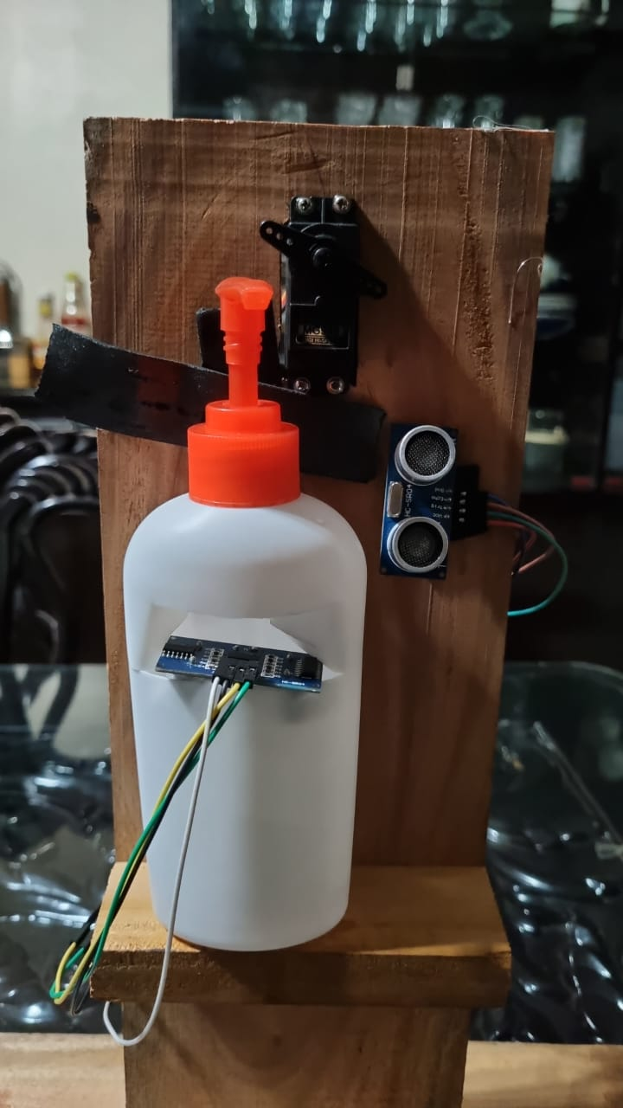

# Implementation

## Description

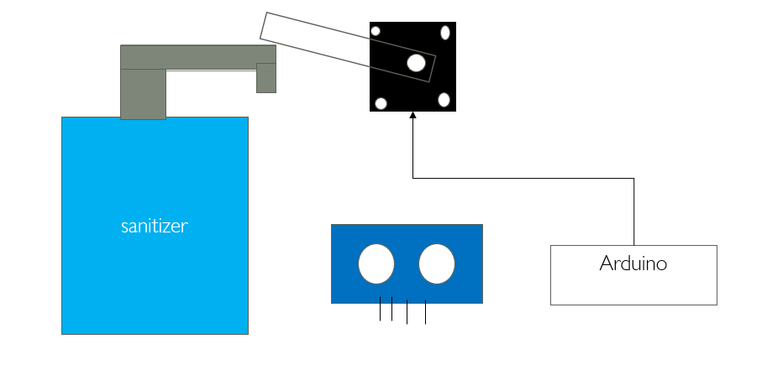

Fig: Implementation of Automatic Hand Wash

# Design Analysis and Evaluation

## Novelty

This Automatic Hand Wash Dispenser is more unique than any other available dispensers because

It has a level indication system and a level indication. If someone tries to touch the dispenser, the buzzer will be on . The level indicator gives indication whenever the level goes below the threshold value.

## Design Considerations (PO(3))

### Considerations to public health and safety

Automatic hand wash dispensers offer a significant advancement in public health and safety by promoting proper hand hygiene and reducing the spread of germs. Here's how they contribute to these critical aspects:

**Improved Hand Hygiene:**

* **Touchless Operation**: Eliminates the need to touch a potentially contaminated dispenser, minimizing the risk of cross-contamination and the spread of bacteria and viruses.
* **Precise Dispensing**: Consistent and controlled dispensing of handwash ensures adequate coverage and effectiveness of hand cleaning.

**Reduced Risk of Infections**:

* **Reduced Transmission of Pathogens**: By promoting hand hygiene, automatic dispensers contribute to a significant reduction in the transmission of various infectious diseases, including common colds, flu, respiratory illnesses, and foodborne illnesses.
* **Improved Public Health Outcomes**: By fostering a culture of hand hygiene, automatic dispensers can contribute to improved public health outcomes through a reduction in healthcare costs and increased overall well-being.

**Safety Considerations:**

* **Proper Installation and Maintenance**: Dispensers need to be properly installed at an appropriate height and location to ensure accessibility and accurate sensor detection. Regular cleaning and maintenance are crucial to prevent malfunction and hygiene issues.
* **Chemical Safety:** Handwash dispensers should be used with appropriate handwash solutions, adhering to safety guidelines and avoiding harmful chemicals.
* **Accessibility for All:** Dispensers should be designed and positioned to be accessible for individuals with disabilities and varying physical abilities.

Overall, automatic hand wash dispensers play a vital role in promoting public health and safety by encouraging hand hygiene and reducing the spread of germs.

### Considerations to environment

Environmental Considerations for Automatic Hand Wash Dispensers While automatic hand wash dispensers offer significant benefits for public health and safety, it's crucial to consider their environmental impact. Here are some key factors to address:

**Energy Consumption:**

* **Power Source**: Choose dispensers with energy-efficient designs that utilize battery power or low-voltage AC adapters. Consider solar-powered options for further sustainability.
* **Standby Power Draw**: Opt for dispensers with low standby power consumption to minimize energy waste when not in use.

**Water Usage**:

* **Sensor Accuracy:** Ensure the sensor accurately detects hand presence to avoid unnecessary dispensing and water waste.
* **Dispensing Amount**: Adjust the dispensing volume to provide sufficient handwashing without excess water usage.

**Waste Generation:**

* **Handwash Refill Options**: Select handwash solutions that come in recyclable or refillable containers to reduce packaging waste.
* **Dispenser Disposal**: Choose dispensers made from recycled materials or those with readily recyclable components when reaching the end of their lifespan.

**Material Sustainability:**

* **Dispenser Body:** Opt for dispensers made with durable, long-lasting materials like stainless steel or recycled plastics to minimize waste from replacements.
* **Sensor and Actuator Components:** Choose components with minimal environmental impact in terms of production, use, and disposal.

### Considerations to cultural and societal needs

While automatic hand wash dispensers offer numerous benefits, their implementation needs to be mindful of cultural and societal needs to ensure inclusivity and effectiveness. Here are some key considerations:

**Accessibility and Usability**:

* **Design:** Dispensers should be designed with diverse users in mind, including children, the elderly, and individuals with disabilities. This may involve features like adjustable height, multiple sensor types (infrared and ultrasonic), and clear visual or audio feedback.
* **Cultural Preferences**: Certain cultures may have specific handwashing practices or beliefs. The design and operation of the dispensers should be culturally sensitive and avoid imposing any discomfort or conflicting with established rituals.
* **Language Barriers**: In multicultural environments, clear signage and instructions on the dispenser should be available in multiple languages to ensure understanding and proper usage.

**Privacy and Hygiene Concerns**:

* **Data Privacy:** Some dispensers collect user data, and it's crucial to ensure transparent data practices with clear information about data collection, usage, and storage.
* **Hygiene Perception**: In some cultures, the touchless nature of automatic dispensers might be perceived as less hygienic than traditional soap bars. Educational campaigns and awareness initiatives can address these concerns.
* **Maintenance and Cleanliness:** Regular cleaning and maintenance of dispensers are crucial to maintain proper hygiene standards and avoid negative perceptions.

## Investigations (PO(4))

### Design of Experiment

The design of the experiment involves configuring the ultrasonic sensor, servo motor, and buzzer in a systematic manner to function the project. The experiment aims to validate the accuracy and reliability of the technology in detecting object and spray the liquid accordingly.

### Data Collection

|  |  |  |  |
| --- | --- | --- | --- |
| No of Attempts | No of Success | No of failure | Accuracy(In percentage) |
| 100 | 98 | 2 | 98 |

### Results and Analysis

From the data we can see that, out of 100 attempts 98 times the device successfully worked meaning it was able to generate chemicals.

### Interpretation and Conclusions on Data

This device is highly accurate and portable for using. According to the data, it all the components worked perfectly well.

## Limitations of Tools (PO(5))

* **Initial Cost:** The initial cost for this project is high .Installing an automatic dispenser system using Arduino can be higher compared to traditional manual dispensers.
* **Power Dependency:** It requires a constant power source.
* **Skill Requirement:** Installing and maintaining an Arduino-based system may require technical expertise.

## Impact Assessment (PO(6))

### Assessment of Societal and Cultural Issues

This technology positively impacts society by providing an affordable and efficient solution for Hand wash service. Its potential applications in safety-critical environments contribute to societal well-being, while the user-friendly interface enhances accessibility.

### Assessment of Health and Safety Issues

This device holds a significant role regarding maintenance of hygiene. Its helps to wash to wash hands without touching a single thing.

## Sustainability Evaluation (PO(7))

Sustainability Evaluation of Automatic Hand Wash Dispensers

Automatic hand wash dispensers offer significant benefits for public health and hygiene. However, their sustainability impact must be carefully evaluated across environmental, cultural, and socioeconomic dimensions. Here's a comprehensive analysis:

**Environmental Sustainability**:

**Reduced water consumption:** Precise dispensing and sensor accuracy promote efficient water utilization.

**Waste reduction:** Refillable dispensers and biodegradable handwash minimize waste generation.

Lower energy consumption: Choosing energy-efficient models and solar-powered options reduces environmental impact.

## Ethical Issues (PO(8))

While automatic hand wash dispensers offer undeniable benefits for public health and hygiene, their implementation raises several ethical concerns that need careful consideration. Here are some key issues:

**Data Privacy and Security:**

**Data collection:** Some dispensers collect data on user interactions, including handwashing frequency and location. This raises concerns about data privacy and potential misuse of personal information.

**Transparency and consent:** Users should have clear information about what data is being collected, how it is used, and how long it is stored. Explicit consent should be obtained before collecting any personal data.

**Security vulnerabilities**: Dispensers connected to networks or storing data on local devices could be vulnerable to hacks and breaches. Robust security measures are crucial to protect user privacy.

*.*

# Reflection on Individual and Team work (PO(9))

## Individual Contribution of Each Member

|  |  |  |  |
| --- | --- | --- | --- |
| Sl | Roll | Name | Contribution |
| 1. | 201916083 | Lt Olid Murad | Hardware Implementation, Presentation |
| 2. | 202116072 | Nasif Ahmed Rafe | Coding, Report Writing |
| 3. | 202116082 | Safin Tahmid | Coding, Presentation |
| 4. | 202116160 | Flg Offr Imran Hossain | Hardware Implementation, Report Writing |

## Mode of TeamWork

In our Project main tasks were delegated between the members. Thereby, it helped us to efficiently finish the project with little hassle. Team members work together seamlessly, sharing ideas, responsibilities, and tasks to ensure a cohesive and efficient project development process. Our Primary element for teamwork was proper Communication.

## Diversity Statement of Team

Different ideas and experiences are core feature of out team. They make us better and more creative. We believe in unique and distinguishable ideas in our project. Together, our differences make us stronger and help us achieve the best result.

## Log Book of Project Implementation

|  |  |  |  |  |
| --- | --- | --- | --- | --- |
| **Date** | **Milestone achieved** | **Individual Role** | **Team Role** | **Comments** |
| 22/09/2023 | Initial Meeting | All members | Planning | Identify Each Team member roles |
| 2/11/2023 | Gathering of hardware | Lt Olid Murad | Collaboration in Resource Gathering | Collecting Components. |
| 10/11/2023 | Upgradation of Project | Flg Offr Imran, Safin Tahmid | Adjust Protection system | Make Necessary change for protection system |
| 12/11/2023 | Coding | Safin Tahmid | Collaboration in Coding | Writing and testing full Code |
| 15/11/2023 | Implementing Mechanism for output | Flg Offr Imran,Nasif Ahmed Rafe | Finding Proper placement of actuator for it work | Necessary Mechanism to display output |
| 20/11/2023 | Design Modification | Nasif Ahmed Rafe, Lt Olid Murad | Making the project Neat and displayable | Adjust the component for better outlook |
| 01/12/2023 | Final Testing and Verification | All members | Check result and verify with the preset value | Changing the variable to check if the project work at all condition |
| 05/12/2023 | PowerPoint Presentation and Project Report | All members | Adding block diagram and necessary figures for easier explanation | Each member equally contributed in Project Report. |

## 7 Communication to External Stakeholders (PO(10))

## 7.1 Executive Summary

FOR PRESS RELEASE

Automatic Hand Wash Dispenser Introduces Innovative Automatic Hand Sanitizer with Intelligent Protection System

Dhaka, 10 December,2023 — Automatic Hand Wash Dispenser, a hygiene solution, proudly unveils its latest breakthrough – the Automatic Hand Sanitizer with an Intelligent Protection System. This cutting-edge device not only dispenses sanitizer automatically for a touch-free experience but also incorporates a smart protection system. The built-in sensor triggers a buzzer alert when the sanitizer level is low, ensuring a constant and reliable supply. This revolutionary product not only enhances safety and hygiene but also simplifies maintenance. Embrace a new era of cleanliness with Automatic Hand Sanitizer – where innovation meets protection.

For more information, contact:

Flg Offr Imran Hossain

01601810488

24imranrafid@gmail.com

## 7.2 User Manual

1. Installation: Place the device on a flat surface near a power source.
2. Power On/Off: Press the power button to toggle the device on or off.
3. Ultrasonic Sensor Activation: Place your hand in front of the sensor, triggering automatic sanitizer release.
4. Sanitizer Dispensing: Ensure your hand remains in the sensor range until the process completes.
5. Buzzer Alert: A buzzer rings if sanitizer falls below a certain level, signaling the need for a refill.
6. Refilling: Turn off the device, open the compartment, and pour sanitizer gently.

## 7.3 Github Link

<https://github.com/Nasifrafe/Nasifrafe/blob/main/sketch_dec10a.ino>

## 7.4 YouTube Link

<https://www.youtube.com/watch?v=YQ7vAuRoV9Q>

# 8 Project Management and Cost Analysis (PO(11))

## 8.1 Bill of Materials

|  |  |  |
| --- | --- | --- |
| Sl No | Materials | Unit Cost(Tk) |
|  | Breadboard | 90 |
|  | Arduino Nano | 600 |
|  | Ultrasonic Sensor (2) | 95 x 2 |
|  | Servo Motor | 350 |
|  | Jumper Wire(20) | 50 |
|  | Wood | 400 |

## 8.2 Calculation of Per Unit Cost of Prototype

Tk 90 + Tk 600 + Tk 190 + Tk 350 + Tk 50 + Tk 400 = Tk 1680

## 8.3 Calculation of Per Unit Cost of Mass-Produced Unit

|  |  |  |
| --- | --- | --- |
| Sl No | Materials | Unit Cost(Tk) |
|  | Breadboard | 80 |
|  | Arduino Nano | 550 |
|  | Ultrasonic Sensor (2) | 85 x 2 |
|  | Servo Motor | 300 |
|  | Jumper Wire(20) | 45 |
|  | Wood | 250 |
|  | Total | 1395 |

# 9 Future Work (PO(12))

More upgradation can be done with the amount of pin available in Arduino Nano. This includes:

1. Adding Sanitization level with LED lights.
2. Adding indication to give notification of approximate days to refill
3. Connecting with IoT would enable to display the status of sanitizer in mobile/laptops.
4. Customization and Personalization feature can be added for identifying amount of sanitizer for each user.
5. Security system can be implemented to avoid unnecessary release of sanitizer.

# 10 References

* <https://www.ijert.org/review-on-automatic-sanitizer-dispensing-machine>
* <https://www.youtube.com/watch?v=Zkya3y1EPbE&pp=ygUdYXV0b21hdGljIGhhbmQgd2FzaCBkaXNwZW5zZXI%3D>